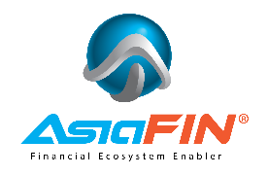

AsiaFIN’s Partner D’Voyager and Faysal Bank Sign Strategic Partnership to Accelerate Digital Banking in Pakistan

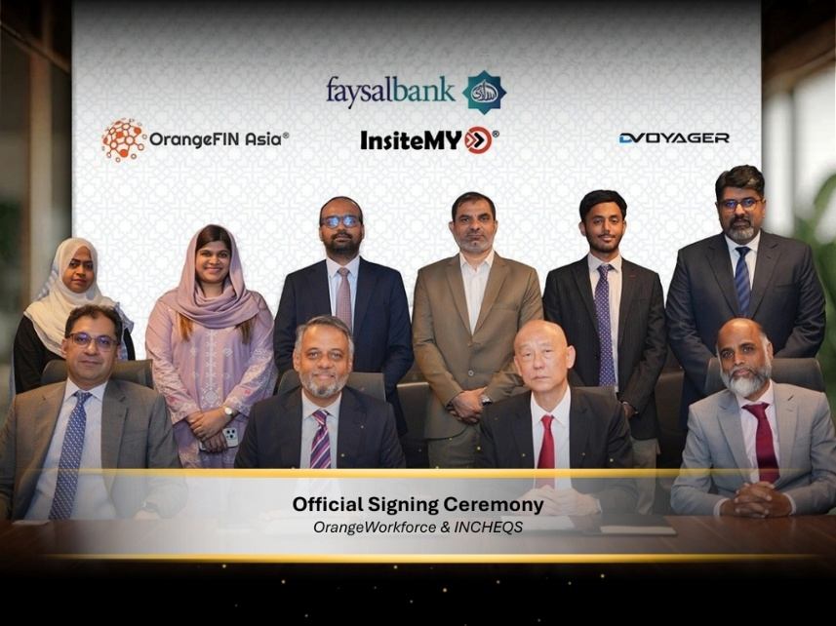

New York, September 30, 2026 – AsiaFIN Holdings Corp. (OTCQB: ASFH), a Financial Ecosystem Enabler, today announced that its Pakistan distributor, D’Voyager, Inc. has signed a strategic agreement with Faysal Bank Limited for AsiaFIN solutions from Insite MY Systems (InsiteMY) and OrangeFIN Asia (OrangeFIN).

The signing ceremony was held at Faysal Bank Limited Head Office, Shahrah-e-Faisal, Karachi, Pakistan, and was attended by Kai Cheong Wong (KC Wong), Founder & CEO, AsiaFIN Holdings Corp., Syed Saqib Ahmed, CEO, D’Voyager, and Syed Muhammad Fraz Zaidi, Head of Operations, Faysal Bank Limited, alongside members of the Faysal Bank team.
Under the agreement, Faysal Bank will adopt two of AsiaFIN’s solutions: INCHEQS, an AI-enabled cheque processing platform developed by InsiteMY, and OrangeWorkforce, a robotic process automation (RPA) solution by OrangeFIN. The solutions aim to digitalise cheque processing and automate the bank’s 200+ other manual processes.
“Faysal Bank is a marquee name in Pakistan’s financial services landscape, and this partnership marks a significant milestone in AsiaFIN’s regional growth. Pakistan represents a key growth market for us, and our collaboration with D’Voyager has been instrumental in building the right partnerships on the ground. D’Voyager has been AsiaFIN’s partner in Pakistan since 2013 and has sold our solutions to three other large banks in the country. We are proud to bring INCHEQS and OrangeWorkforce to Faysal Bank and look forward to their automation success,” said KC Wong, AsiaFIN Holdings Corp.

“Faysal Bank is committed to advancing our transformation agenda by modernising our back-office and cheque processing operations. The adoption of INCHEQS and OrangeWorkforce represents a significant step forward, and we are confident these solutions will bring meaningful operational efficiencies,” commented Syed Muhammad Fraz Zaidi, Faysal Bank Limited.

“Our hard work and perseverance have paid off with Faysal Bank being our fourth bank customer in Pakistan for INCHEQS and third bank customer in Pakistan for OrangeWorkforce. Faysal Bank started using our OrangeWorkforce RPA solution before selecting our INCHEQS digital cheque clearing solution, reflecting the bank’s focus on automation and AI,” said Syed Saqib Ahmed, CEO, D’Voyager.

This agreement further strengthens AsiaFIN’s presence in Pakistan’s financial services market. InsiteMY expanded into the South Asia region in 2009, entering Bangladesh and India before establishing a presence in Pakistan. AsiaFIN currently provides services across nine markets, including Malaysia, Myanmar, Singapore, the Philippines, Thailand, Indonesia, Pakistan, Bangladesh and Saudi Arabia. AsiaFIN plans to expand further into newer markets in the Middle East and the Americas.

About AsiaFIN Holdings Corp.
AsiaFIN Holdings Corp. (OTCQB: ASFH), a Nevada corporation, operates through its wholly owned subsidiaries in Malaysia, Hong Kong, and the British Virgin Islands. AsiaFIN’s mission is to become the “financial ecosystem enabler” through its solutions in Fintech; Regulatory Technology (RegTech); ESG Consultancy & Reporting and Robotic Process Automation (RPA) services. AsiaFIN provides services to more than 90 financial institutions and over 100 corporate clients in the Asia and Middle East region including Malaysia, Myanmar, the Philippines, Indonesia, Bangladesh, Pakistan, Thailand, Singapore and Saudi Arabia. AsiaFIN’s clients are central banks, financial institutions and large corporations. For further information regarding the company, please visit https://asiafingroup.com.

Notice Regarding Forward-Looking Statements
This press release contains forward-looking statements as defined within Section 27A of the Securities Act of 1933, as amended, and Section 21E of the Securities Exchange Act of 1934, as amended. By their nature, forward-looking statements and forecasts involve risks and uncertainties because they relate to events and depend on circumstances that will occur in the near future. Those statements include statements regarding the intent, belief or current expectations of AsiaFIN and members of its management as well as the assumptions on which such statements are based. Prospective investors are cautioned that any such forward-looking statements are not guarantees of future performance and involve risks and uncertainties, and that actual results may differ materially from those contemplated by such forward-looking statements.

AsiaFIN undertakes no obligation to update or revise forward-looking statements to reflect changed conditions. Statements in this presentation that are not descriptions of historical facts are forward-looking statements relating to future events, and as such all forward-looking statements are made pursuant to the Private Securities Litigation Reform Act of 1995. Statements may contain certain forward-looking statements pertaining to future anticipated or projected plans, performance and developments, as well as other statements relating to future operations and results. Words such as “may,” “will,” “expect,” “believe,” “anticipate,” “estimate,” “intends,” “goal,” “objective,” “seek,” “attempt,” “aim to,” or variations of these or similar words, identify forward-looking statements. These risks and uncertainties include, but are not limited to, risks associated with AsiaFIN’s operating history, recent history of losses and profits, ability to adequately protect its software innovations, dependence on key executives, ability to obtain required regulatory approvals, other factors described in AsiaFIN’s Annual Report on Form 10-K and other factors as may periodically be described in AsiaFIN’s filings with the U.S. Securities and Exchange Commission.

Investors

AsiaFIN Holdings Corp. (OTCQB:ASFH)
KC Wong, Chief Executive Officer
investor.relations@asiafingroup.com

Media
AsiaFIN Holdings Corp. (OTCQB:ASFH)
KC Wong, Chief Executive Officer
media@asiafingroup.com

SOURCE: ASIAFIN HOLDINGS CORP.

- END -

